DAY 1 – XRAY FUNDAMENTALS
1. Introduction to Xray
1.1 What is Xray?
Xray is a test management tool that is natively integrated with Jira. It enables teams to manage manual and automated test cases, execute tests, track results, and generate reports — all within the Jira ecosystem.
Unlike standalone testing tools, Xray treats testing artifacts as Jira issue types, ensuring complete traceability between requirements, test cases, executions, and defects.

1.2 Why Xray Exists
Xray was developed to solve common challenges in software testing:
- Lack of traceability between requirements and test cases
- Difficulty managing tests in Agile and DevOps environments
- Disconnected tools for development and testing
- Poor visibility into test execution and quality metrics
Xray addresses these by:
- Embedding testing directly into Jira
- Supporting Agile, Scrum, Kanban, and CI/CD workflows
- Providing real-time test reporting and insights

1.3 Xray in Agile Projects
In Agile projects, frequent releases require continuous testing. Xray supports Agile by:
- Linking User Stories → Tests → Test Executions
- Supporting Sprint-based testing
- Enabling automation integration with CI tools
- Allowing testers and developers to collaborate in the same tool
This ensures faster feedback, higher quality, and better sprint planning.

1.4 Jira vs Xray (Key Difference)
Aspect | Jira | Xray
Purpose | Project & issue tracking | Test management
Issue Types | Story, Bug, Task, Epic | Test, Test Execution, Test Plan
Testing Support | Very limited | Full testing lifecycle
Reporting | Project-based | Test coverage & execution-based
Automation | Not test-focused | CI/CD & automation ready
👉 Jira manages work; Xray manages quality.

1.5 Real-World Usage of Xray
Xray is widely used in:
- Software product companies
- Banking and financial systems
- Healthcare applications
- E-commerce platforms
- Enterprise SaaS products
Teams use Xray to:
- Ensure requirement coverage
- Track manual & automated testing
- Improve release confidence
- Maintain audit-ready test documentation

2. Xray Architecture

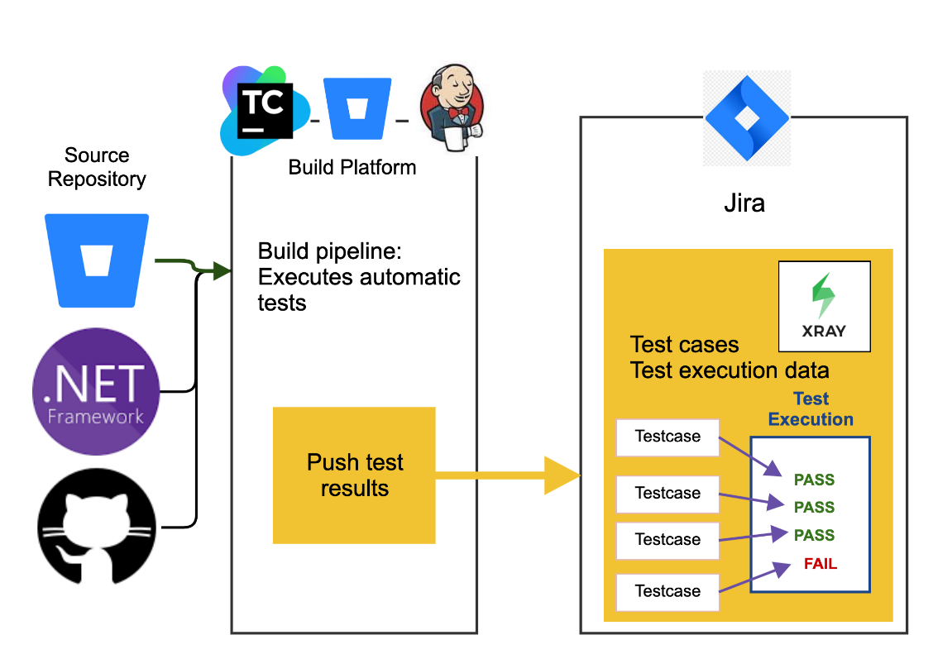

2.1 Xray Cloud
- Hosted by Atlassian
- No infrastructure maintenance
- Automatic updates
- Best for small to medium teams
- Subscription-based licensing

2.2 Xray Data Center
- Installed on company servers
- High performance and scalability
- Advanced security and compliance
- Ideal for large enterprises
- Requires infrastructure management

2.3 Licensing Basics
Xray licensing depends on:
- Jira type (Cloud or Data Center)
- Number of Jira users
- Enterprise requirements
Licenses scale with team size and usage.

2.4 Enterprise Usage Scenarios
Enterprises use Xray for:
- Multi-team test coordination
- Large-scale automation
- Compliance & audit tracking
- Centralized quality dashboards
- CI/CD pipeline integration

3. Xray Core Concepts
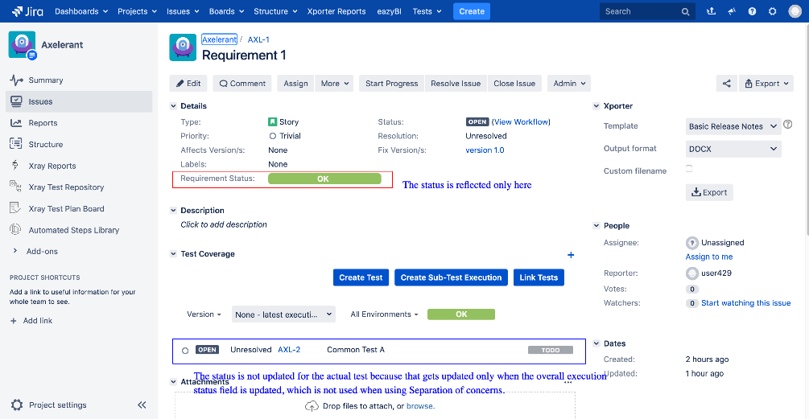
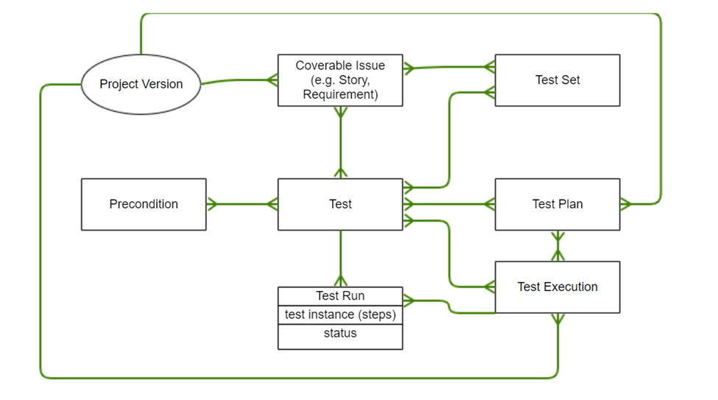
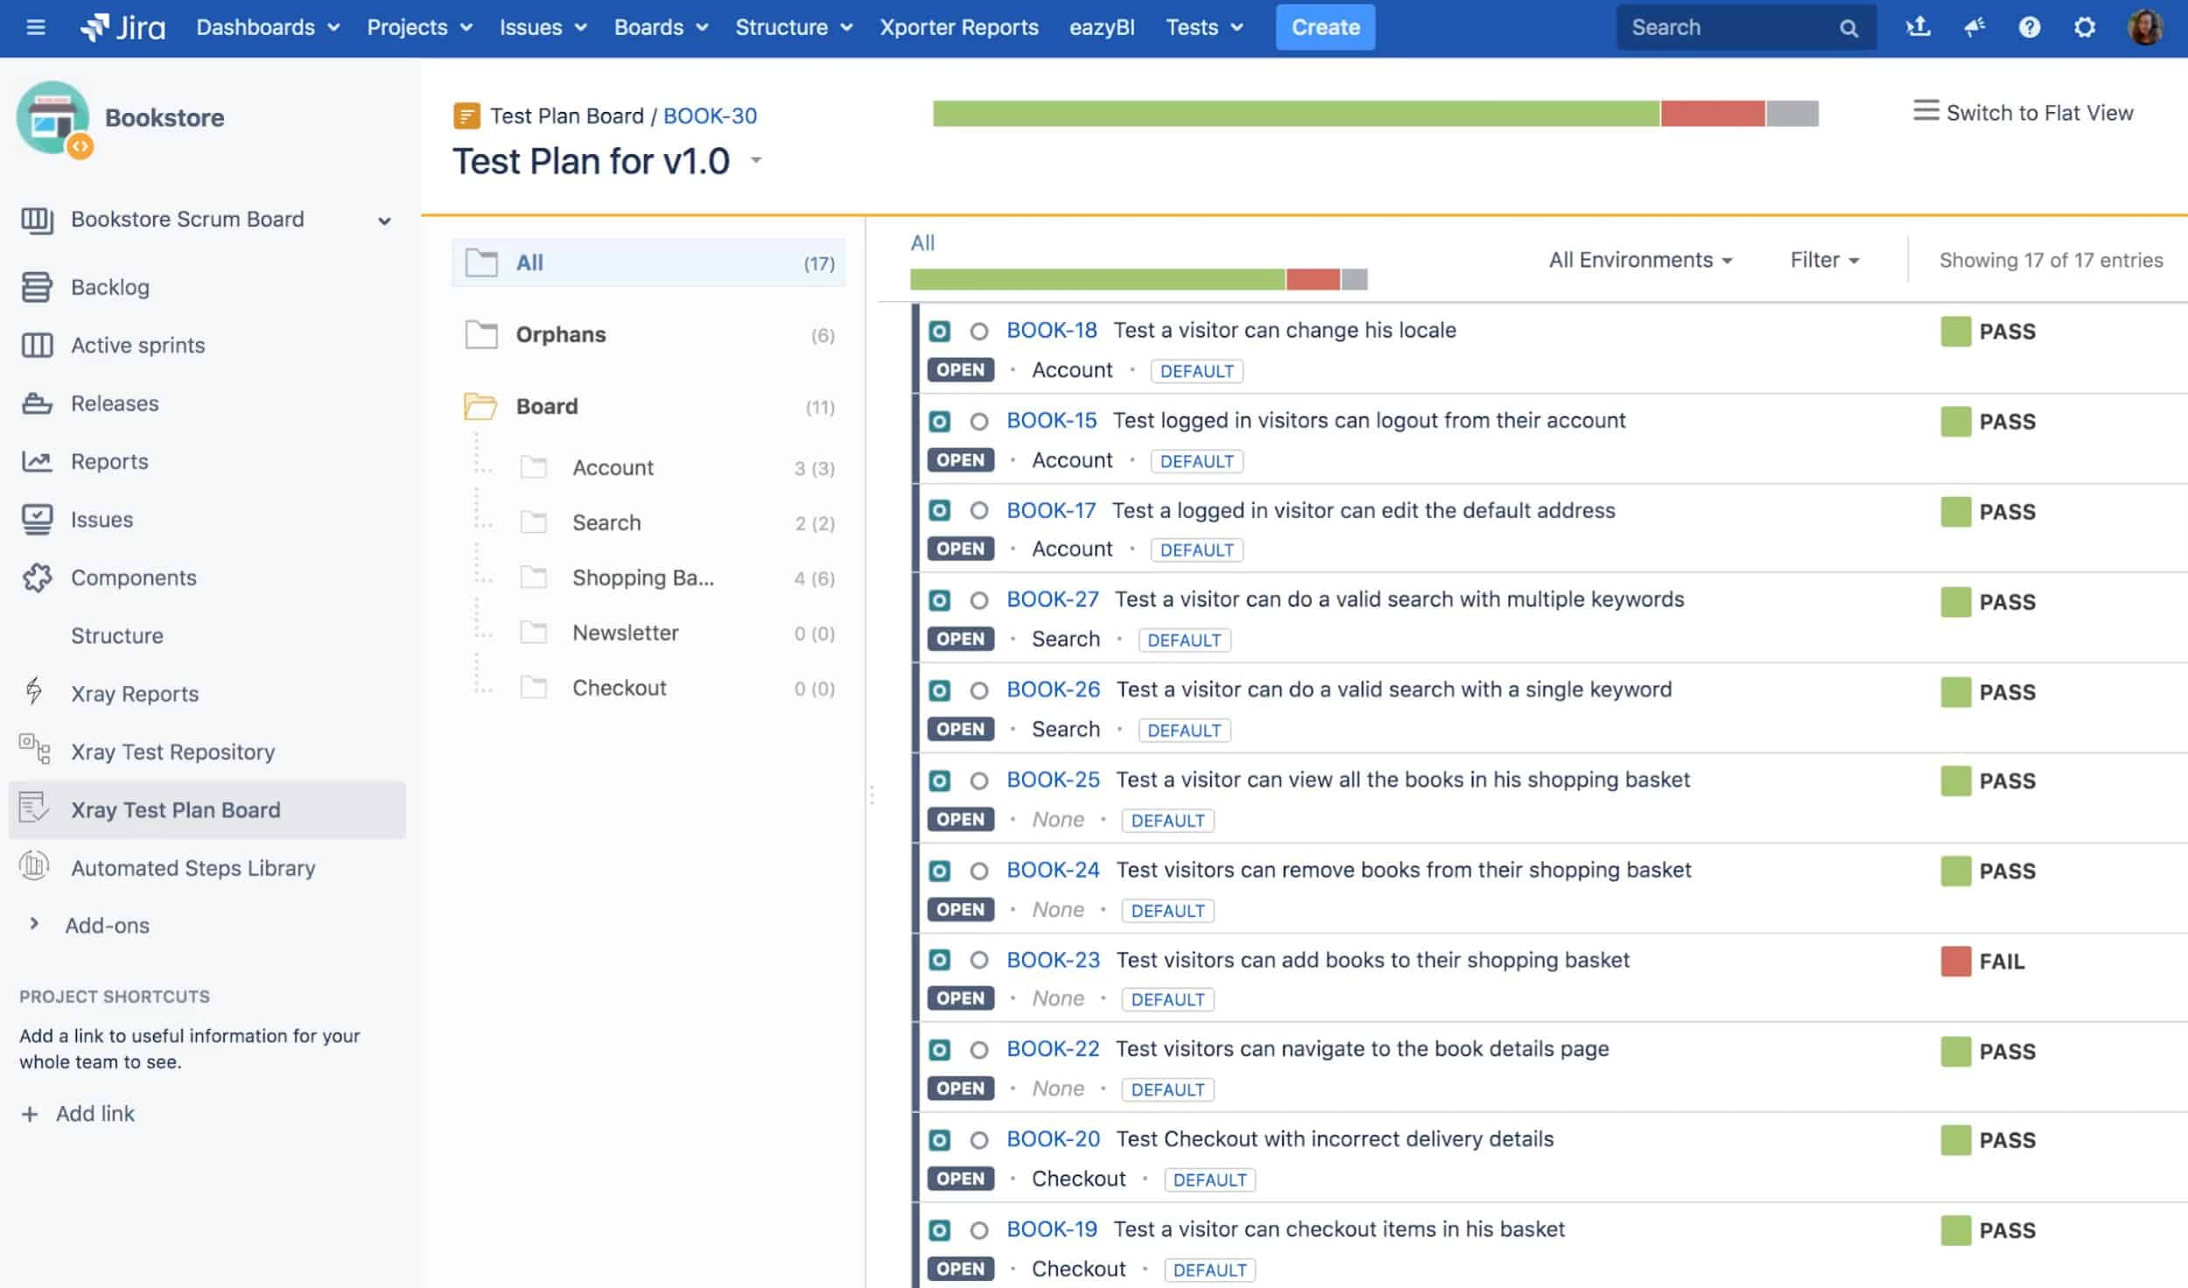

3.1 Test
- Represents a test case
- Can be manual or automated
- Contains steps, expected results, and test type

3.2 Test Execution
- Represents the actual execution of tests
- Stores execution status (Pass/Fail)
- Can include evidence like screenshots or logs

3.3 Test Plan
- Groups tests planned for a release or sprint
- Helps track overall testing progress

3.4 Test Set
- Logical grouping of related tests
- Useful for regression or module-wise testing

3.5 Precondition
- Defines prerequisites required before executing tests
- Can be reused across multiple tests

3.6 Evidence
- Attachments such as screenshots, videos, or logs
- Used to support test results
- Important for audits and defect analysis

4. Tool Comparison
4.1 Xray vs Zephyr
Feature | Xray | Zephyr
Jira Integration | Native | Plugin-based
Automation Support | Strong | Limited
Reporting | Advanced | Basic
Scalability | High | Medium

4.2 Xray vs TestRail
Feature | Xray | TestRail
Jira Dependency | Fully integrated | External tool
Traceability | End-to-end | Partial
Agile Support | Excellent | Moderate
Cost | Jira-based | Separate licensing

4.3 Advantages of Xray
- Native Jira integration
- Strong automation support
- Full requirement traceability
- Suitable for Agile & DevOps
- Enterprise-grade reporting
4.4 Limitations of Xray
- Requires Jira knowledge
- Initial setup complexity
- Cost increases with user count

5. Hands-On Exploration (Day 1 Practice)
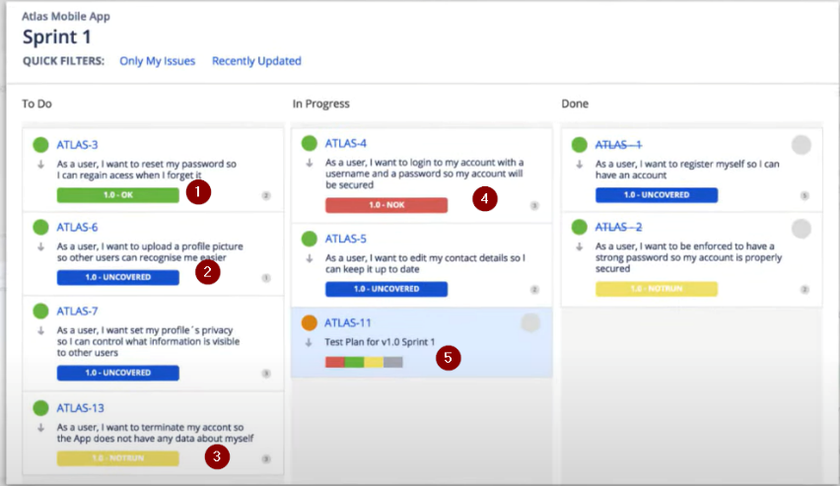
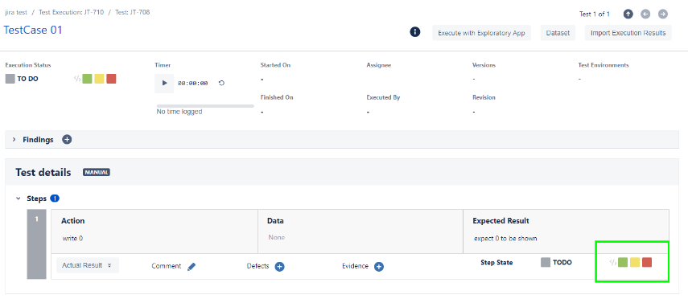
5.1 Explore Xray Menu
- Navigate to Jira → Xray section
- View Tests, Test Executions, Test Plans

5.2 View Sample Tests & Executions
- Open a Test issue
- Check steps, expected results
- Review execution history

5.3 Compare Xray Issues vs Jira Issues
Feature | Story / Bug (Jira) | Test / Execution (Xray)
Purpose | Feature / Defect | Validate functionality
Fields | Description, Priority | Steps, Results, Evidence
Workflow | Development-focused | Testing-focused
Outcome | Done / Fixed | Pass / Fail

